Task 1-GIT Repository

Step 1:- Create a GIT Hub account.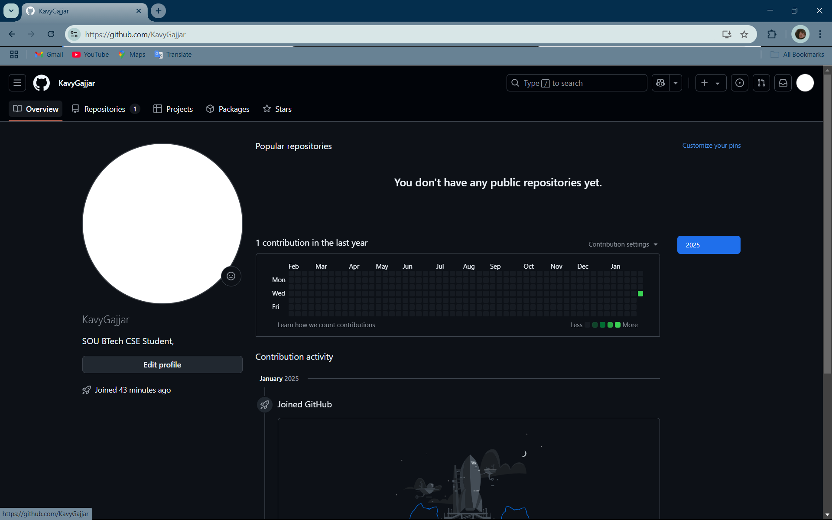

Step 2:- Open repositories section and create a new repository.

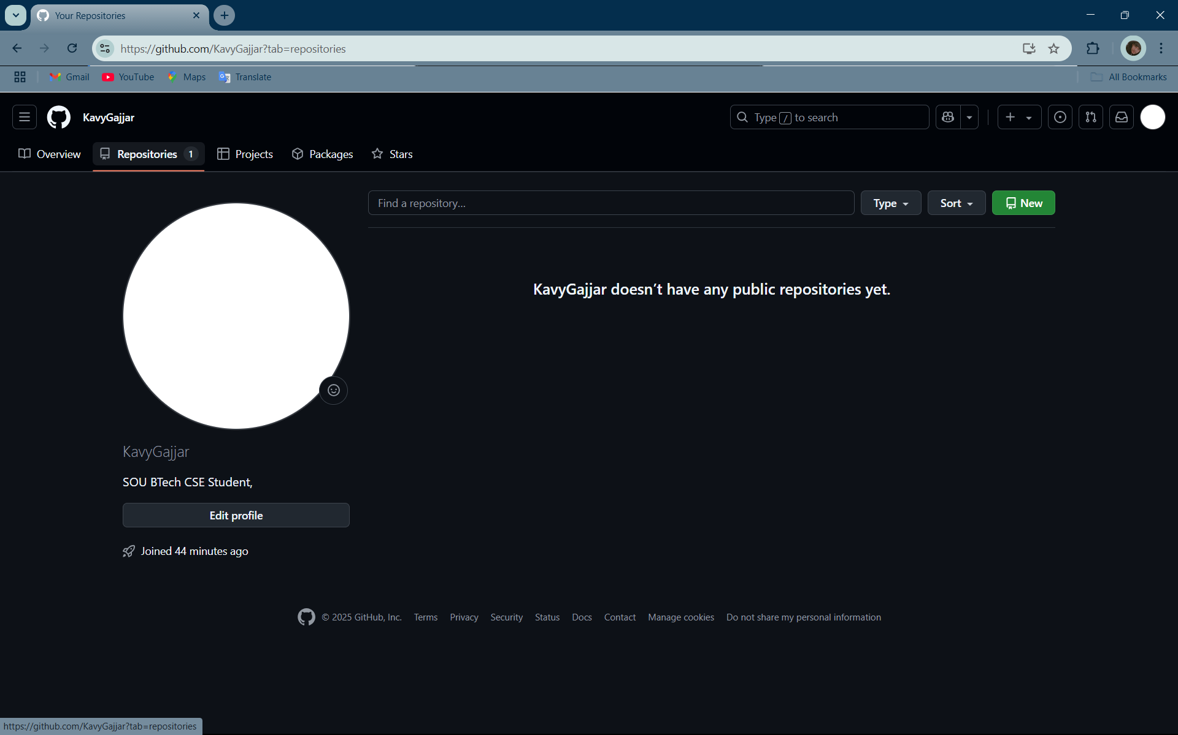

Step 3:- Name repository as enrollment number.

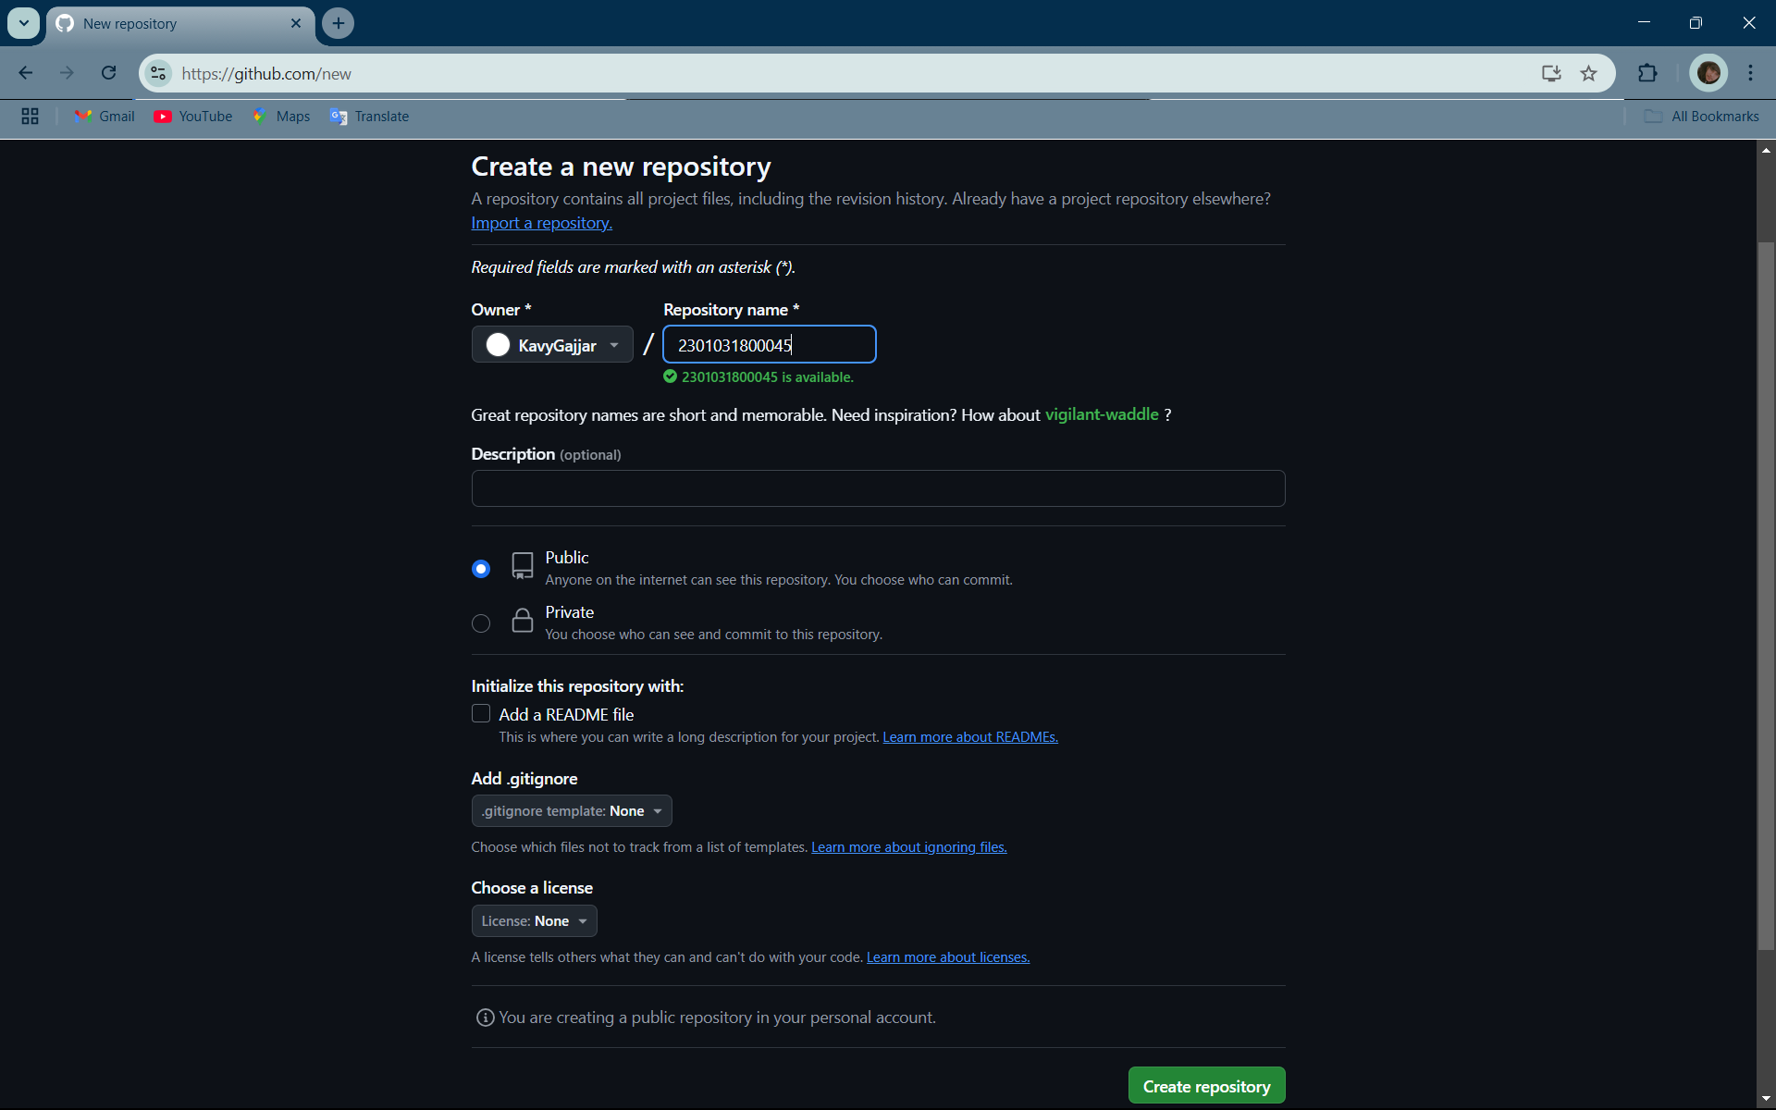

Step 4:- Create 2 folder name as Assignment_1 and Assignment_2.

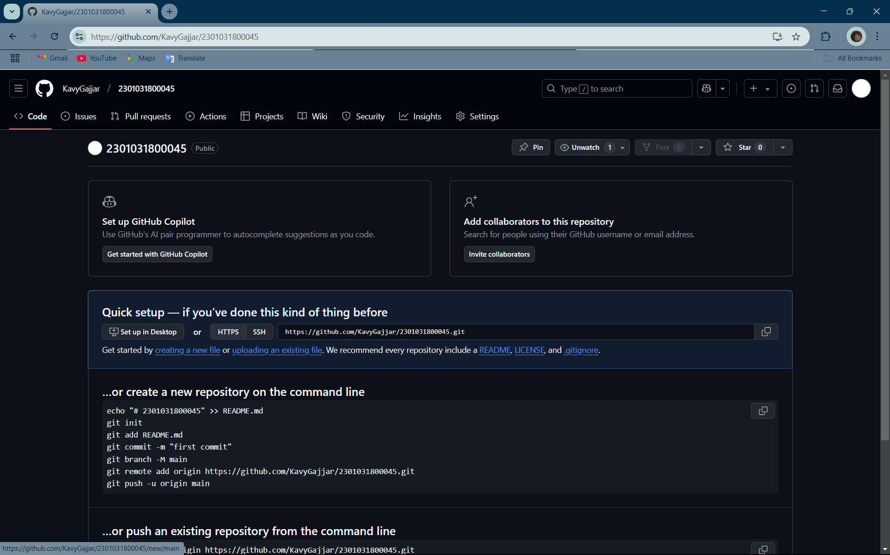

Step 5:- Create folder name Assignment_1 and click on commit changes.

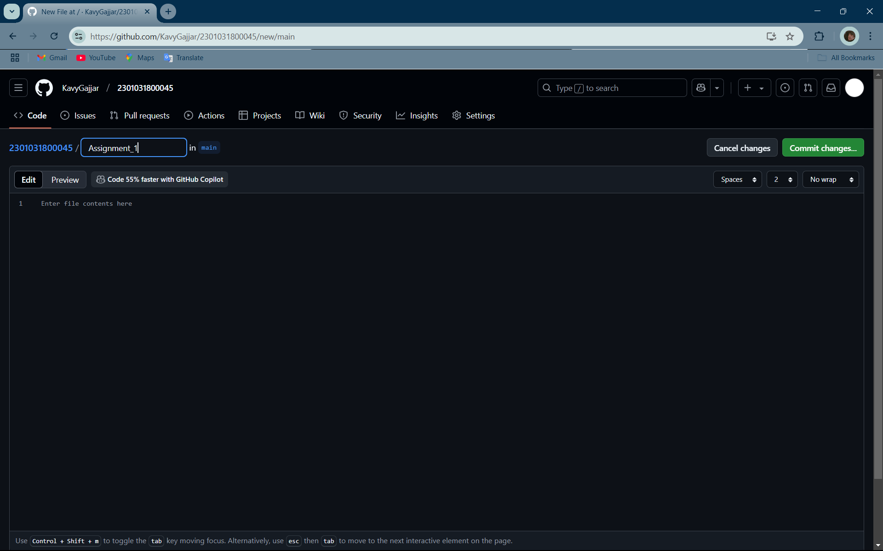

Step 6:-Repeat this with Assignment_2.

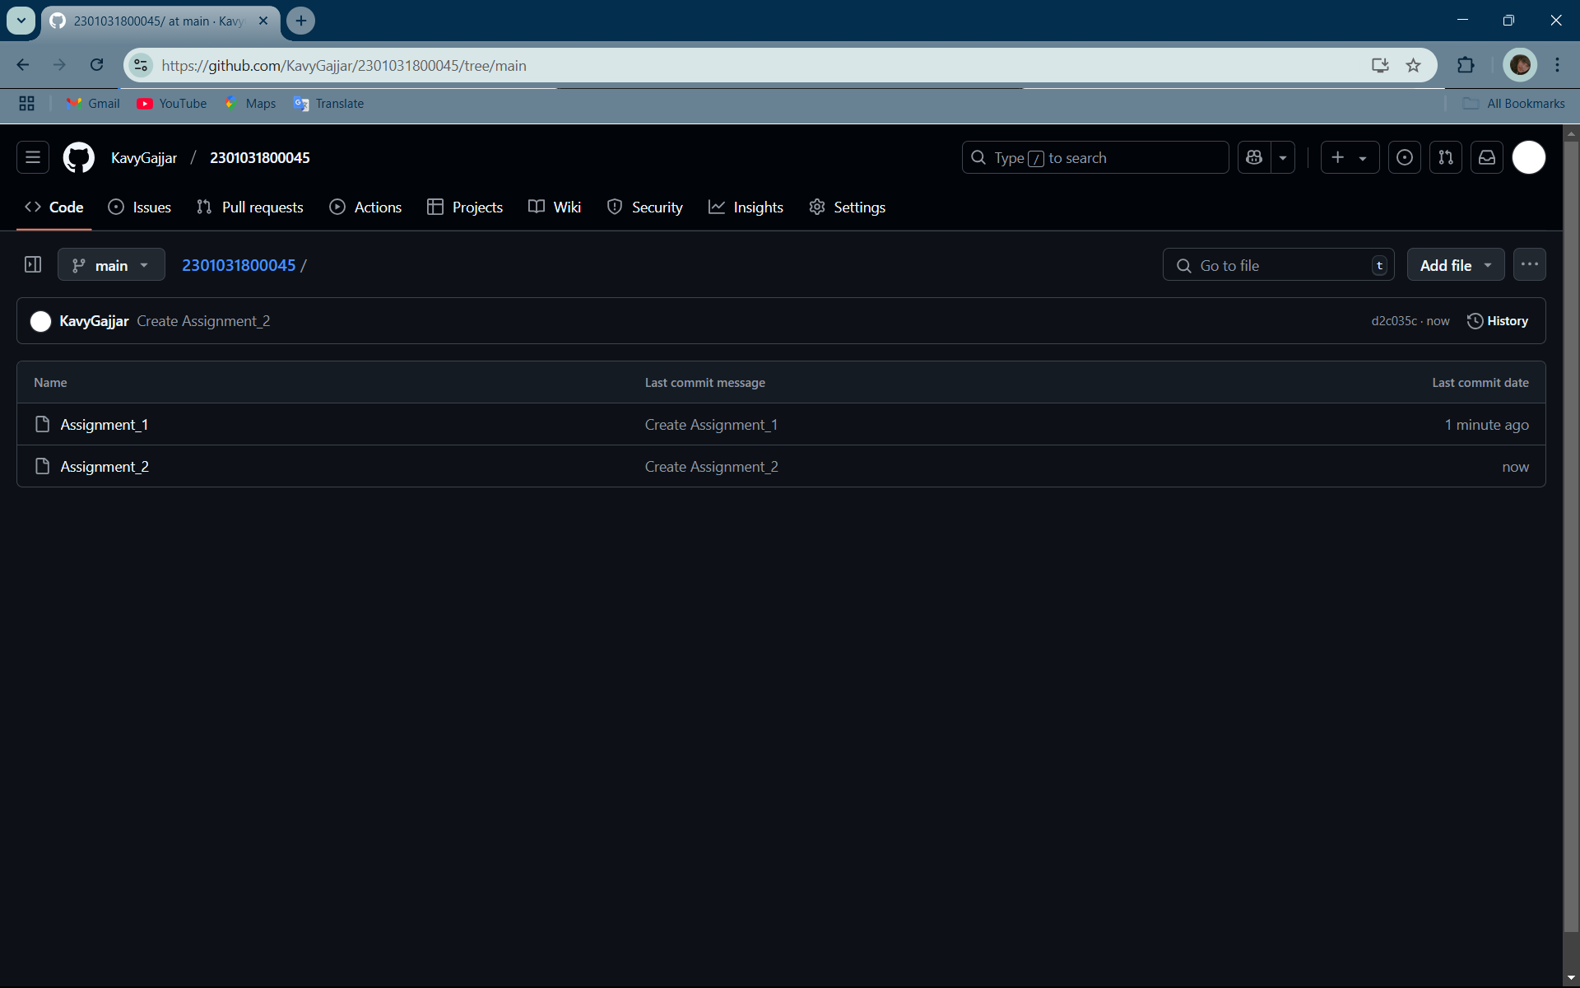

Completed Task 1